ASSIGNMENT

Creating three instances ec1, ec2, ec3

EBS :-

By default, we will get 8GB of storage in an ec1 instance

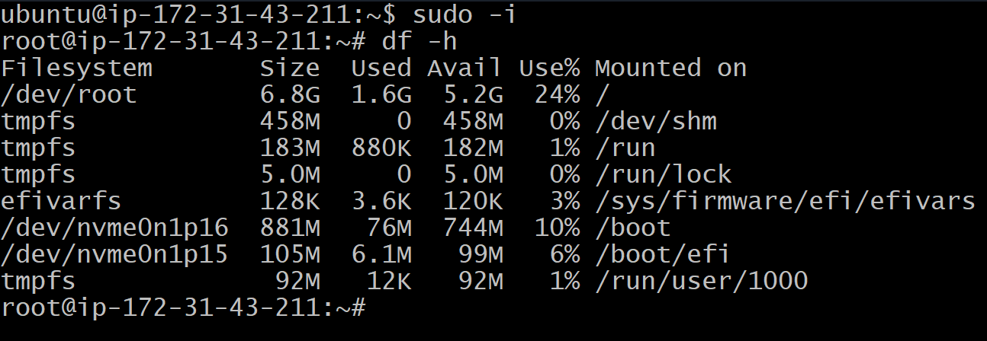

Now we have to create a new ebs volume of 10GB within the same region as ec1(eu-north-1b)



Now press on actions and attach it to the ec1

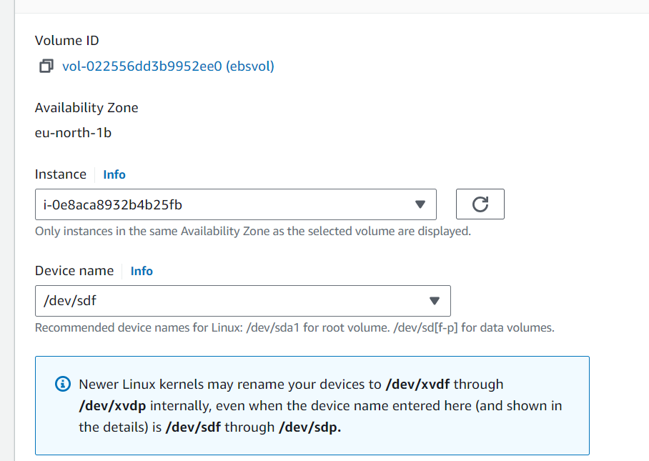

Now restart ec1 instance and connect to the instance

Now we can see the 10GB storage

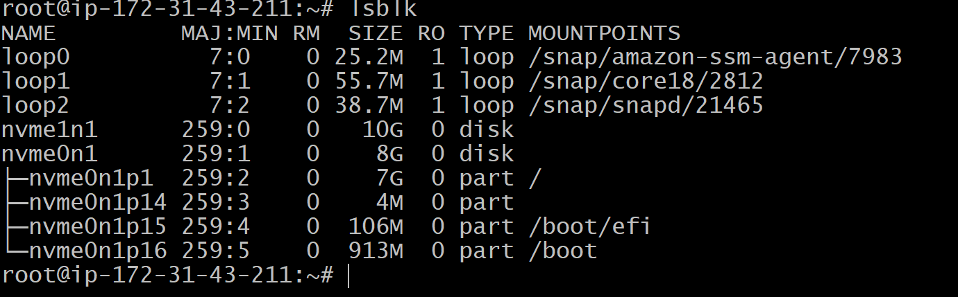

EFS :-

First create a new security group (efs-sg)



Create new file system (my-efs)

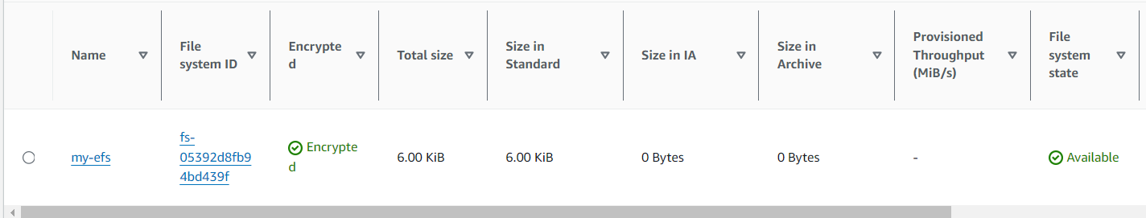

Now launch ec2 instance

Connect to the ec2 instance

cd /mnt/efs/fs1

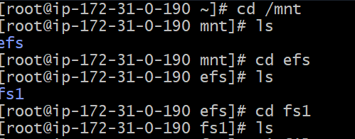

Create new file in ec2 (fs1)

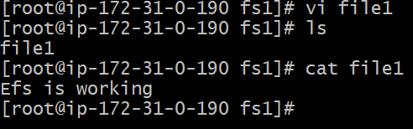

Now launch ec3 with same security group as ec2

Now connect to ec3 instance

cd /mnt/efs/fs1

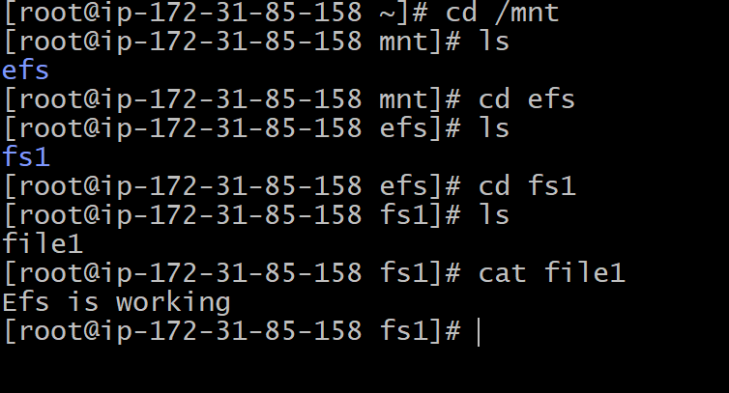

Now we can see file1 in ec3